Unit 1 - Worksheet 1: Defining a “System”

*Refer to your Activity 1 Observation Stations notes to help you recall each of these events.*

**Directions: For each Observation Station listed…**

1. Discuss what objects should be part of the “system” of interest
2. Construct a labeled System Schema for the event and an initial and final state diagram for the event *if applicable*. *If an event diagram is not applicable, state why it is not applicable.*
3. Be sure to include objects that were interacting during the change you observed. Does your system schema represent the interaction? If you think there are interactions with objects outside your “system”, include them and explain your thinking!
4. Tumble Buggy

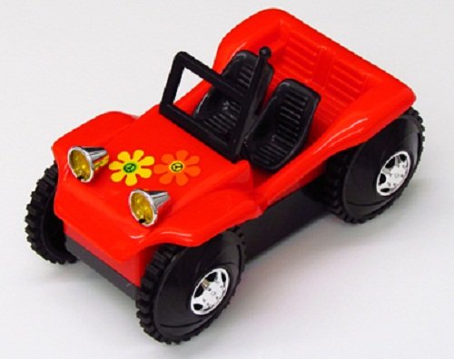

1. 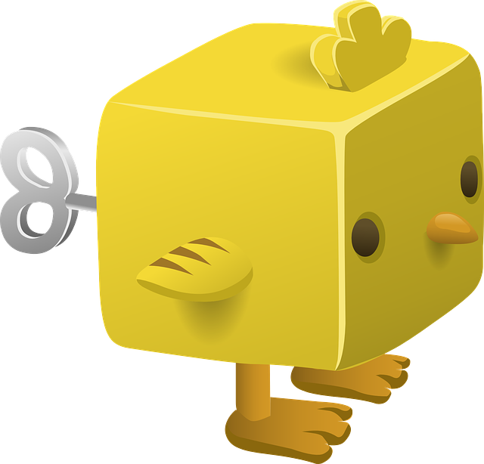Wind-Up Toys
2. Air Puck

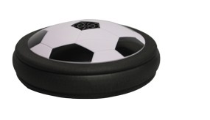

1. Ball Drop
2. Carts on a Track

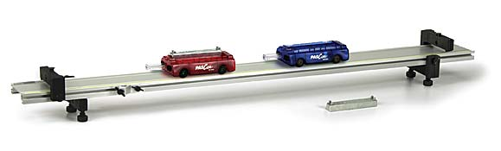

1. Watching Ice Melt
2. 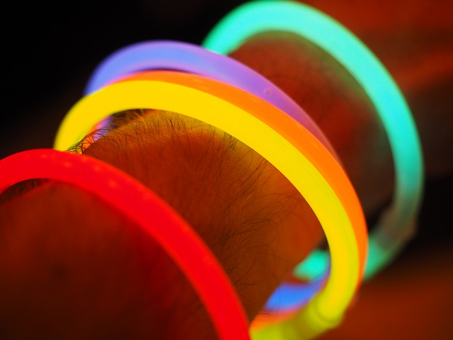Glow Sticks
3. ****Cheetos on Fire
4. 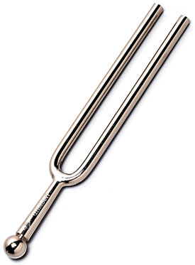Tuning Fork
5. Airzooka

